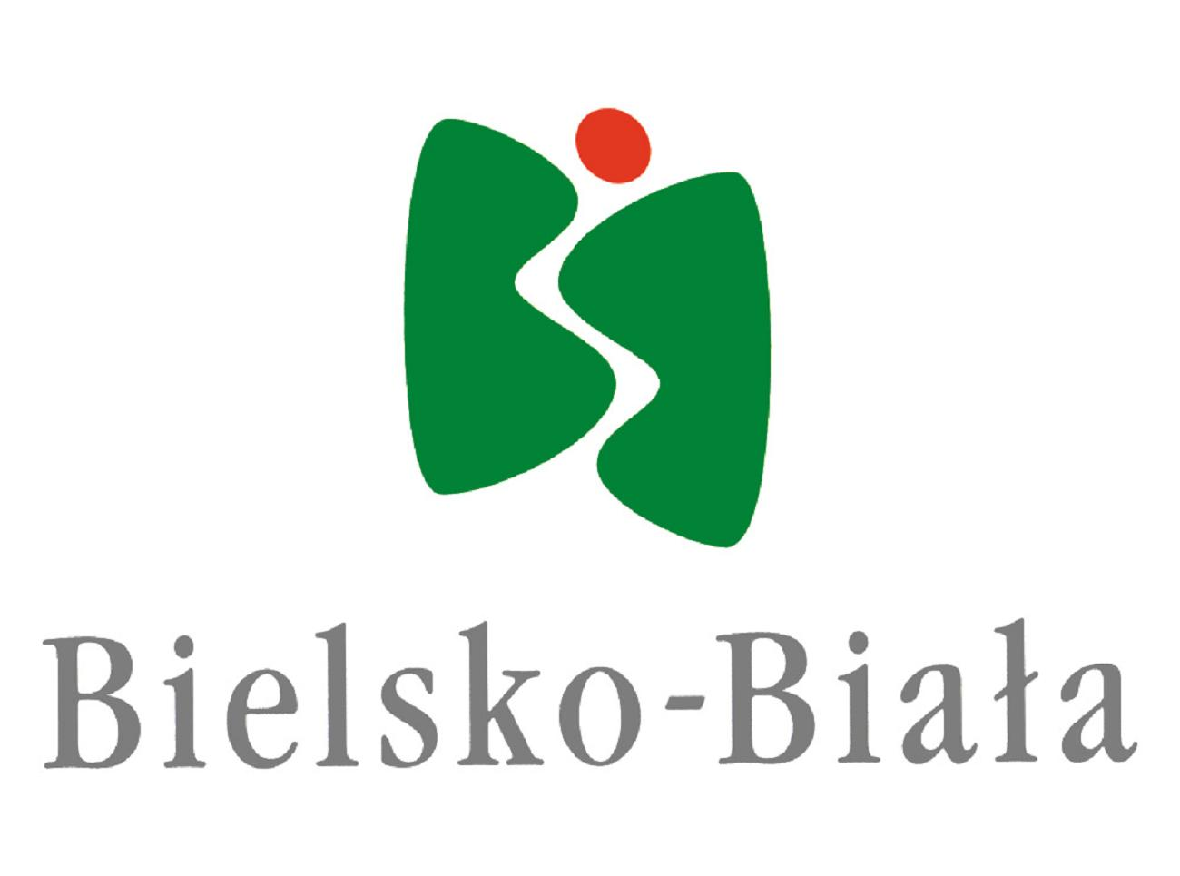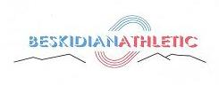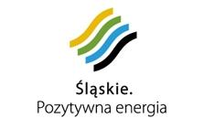

ORGANIZATIONAL COMMUNICATION
XI INTERNATIONAL ATHLETIC MEETING

CHILDREN, CADETTS AND JUNIORS
26.05.2012 BIELSKO BIAŁA

1. ORGANIZER: KS SPRINT BIELSKO BIAŁA
DISTRICT BIELSKO BIAŁA

2. TERM : 26.05.2012 /saturday/ children /99- 2000/
cadetts /97-98/
juniors /93-96/

3. PLACE: Stadion KS SPRINT Bielsko Biała, ul, Jaworzańska 120
tel/fax. /0-33/ 818-32-47
e-mail:klubsprint@poczta.onet.pl;

4. EVENTS :
CHILDREN /99-2000/: Girls – 60m, 300m, long jump
Boys – 60m, 300m, long jump

CADETTS/97-98/: W– 100m, 600m, long jump, shot the put 3kg, javelin 500g
M – 100m, 1000m, long jump, shot the put 5kg, javelin 600g

JUNIORS/93-96/:W – 100m, 200m, 400m, 800m, 1500m, 100m hs, 3- jump, high jump, shot the put /3kg and 4kg/,
M – 100m, 200m, 400m, 800m, 1500m, 110m hs, long jump, high jump, shot the put /5kg and 6kg/,

Athlets can take part in 2 events.

Children – all will have 3 jumps.
Cadetts – all will have 4 tests
Juniors – all will have 3 tests and final for the best 8

If you want more information please write by e-mail.:
klubsprint@poczta.onet.pl
kdobijka@wp.pl

