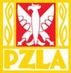
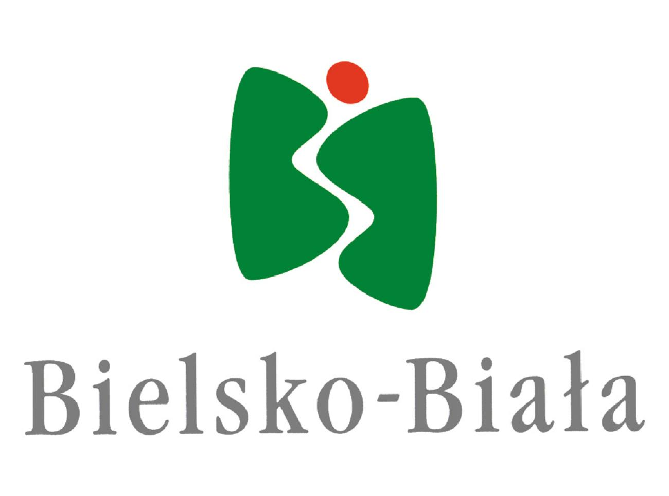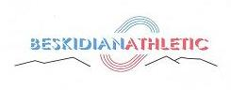

ORGANIZATIONAL COMMUNICATION
XV INTERNATIONAL ATHLETIC MEETING

CHILDREN, CADETTS AND JUNIORS
17.06.2017 BIELSKO BIAŁA

- ORGANIZER: KS SPRINT BIELSKO BIAŁA
POLISH ATHLETIC ASSOCIATION
DISTRICT BIELSKO BIAŁA

2. TERM : 17.06.2017 /saturday/ children /2004 and younger/
cadetts /2002-2003/
juniors /1998-2001/

3. PLACE: Stadion KS SPRINT Bielsko Biała, ul, Jaworzańska 120
tel/fax. /0-33/ 818-32-47
e-mail:klubsprint@poczta.onet.pl;

4. EVENTS :
CHILDERN U12/2006 and younger/ Girls – 60m, 300m
Boys – 60m, 600m

CHILDREN U14/2004-2005/: Girls – 60m, 300m, long jump
Boys – 60m, 600m, long jump

CADETTS U16/2002-2003/: W– 100m, 300m, 600m, long jump, high jump,
shot the put 3kg; discus 0,75 kg.
M – 100m, 300m, 1000m, long jump, high jump,
shot the put 5kg, discus 1kg

JUNIORS YOUNGERS U18 /2000-2001/:
W – 100m, 400m, 800m, 100m hs, triple jump, high jump, pole vault, javelin /500g/, discus /1kg/
M – 100m, 400m, 800m, 110m hs, triple jump, high jump, pole vault, javelin /700g/, discus /1,5kg/
JUNIORS U20/98-99/ : W – 100m, 400m, 1500m, 100m hs, long jump,
shot the put /4kg/, hammer /4kg/.
M – 100m, 400m, 1500m, 3000m, 110m hs, long jump, shot the put /6kg/, hammer /6kg/

Athlets can take part in 2 events.

Children – all will have 3 jumps.
Cadetts – all will have 4 tests
Juniors – all will have 3 tests and final for the best 8

Starts list should be sending by e-mail till 12.06.2016 - klubsprint@poczta.onet.pl
Name – surname – year of birth- event – personal/season best

If you want more information please write by e-mail.:
klubsprint@poczta.onet.pl
kdobijka@wp.pl
